**Developing Grafana Dashboard for Prometheus Metrics :**

**Process:**

**Set Up AWS Resources**

Logged in to AWS Management Console.  
• Launched EC2 Instance: (virtual machine - Ubuntu).

And security groups to allowed HTTP (port 80) and SSH (port 22) traffic with instance type - T2.medium and 15Gb disk size and created PPK file.

**Connect to Your EC2 Instance**

•    Used SSH to connect to EC2 instance using the PPK file via Putty as below.

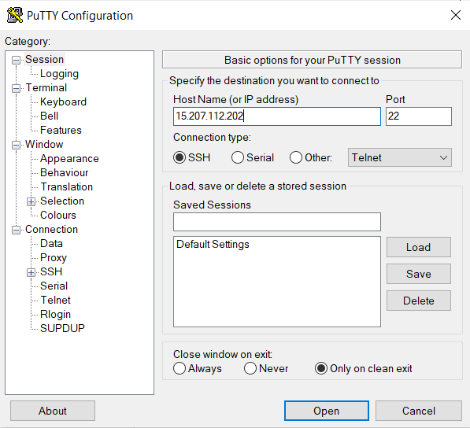

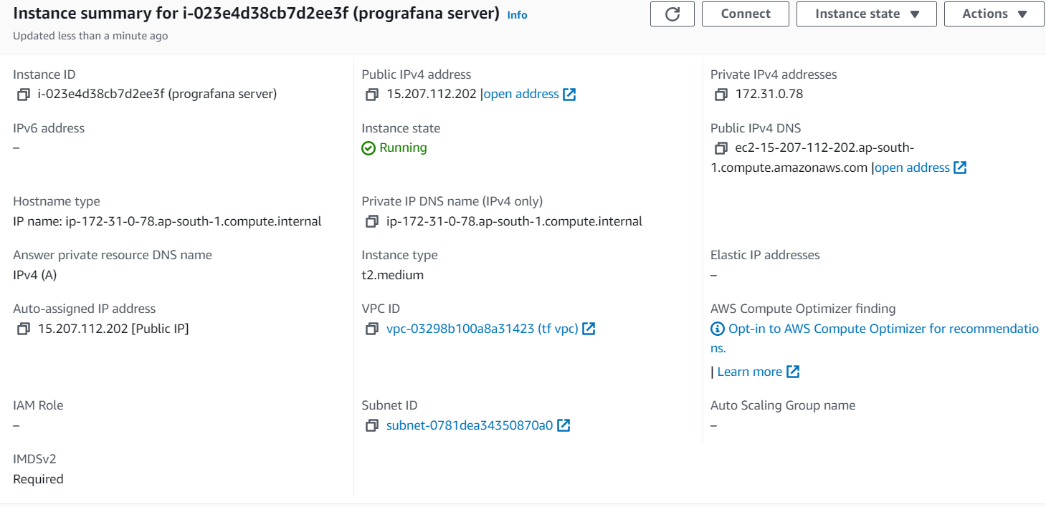

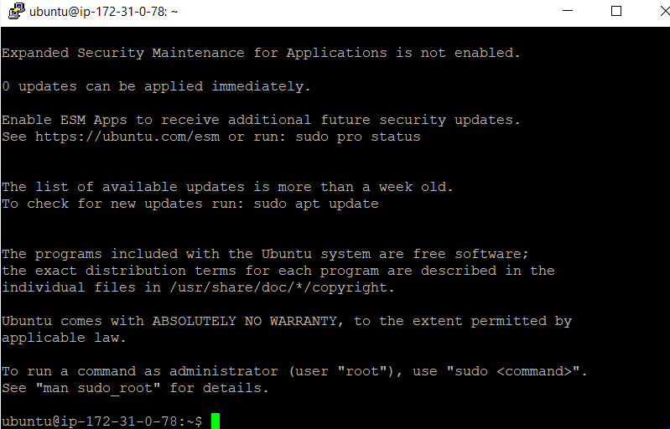

First installed Prometheus on the machine

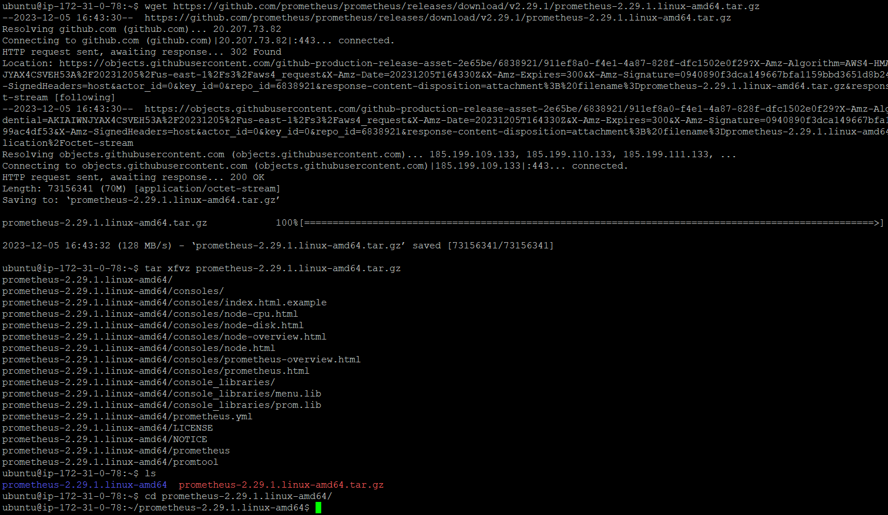

After installing Prometheus we start the Prometheus using following command

./prometheus

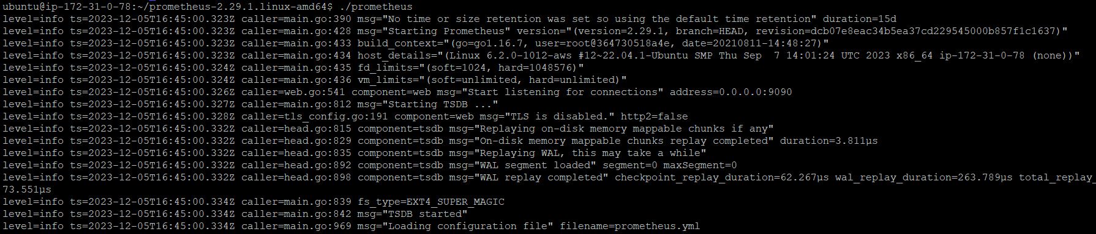

Added 9090 port open for the accessing Prometheus server as below

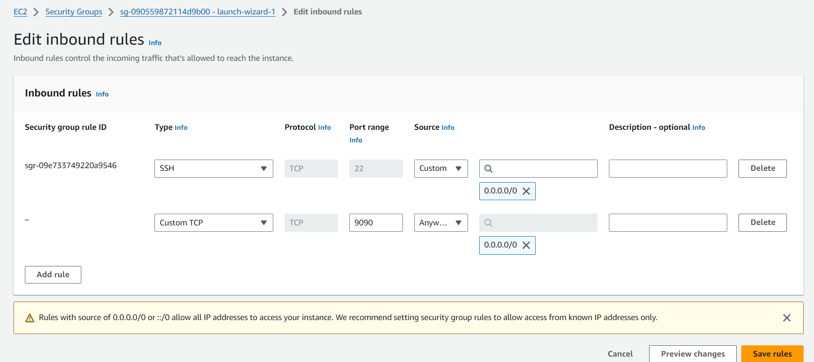

Accessed Prometheus

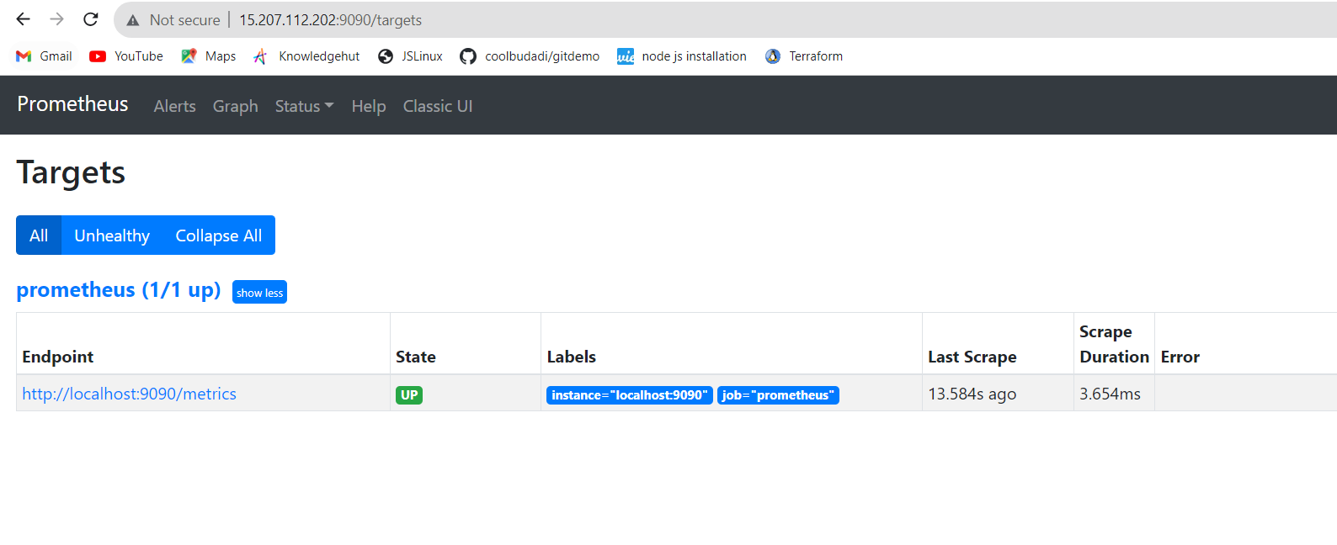

**Installed Grafana on the machine**

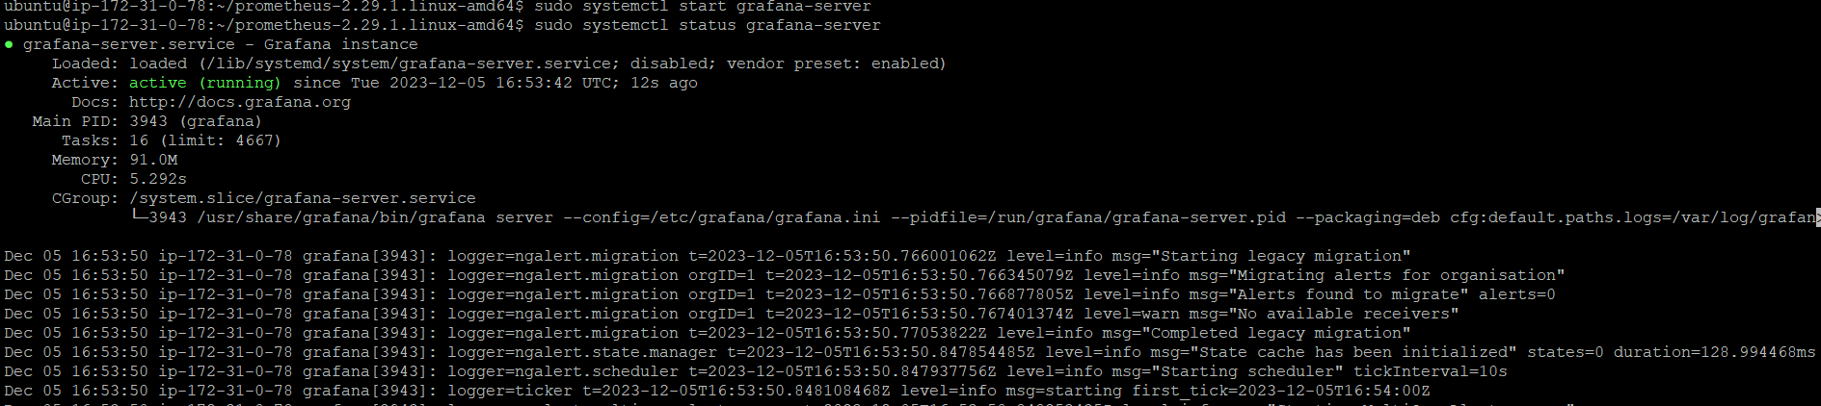

Added 3000 port open for the accessing grafana server as below

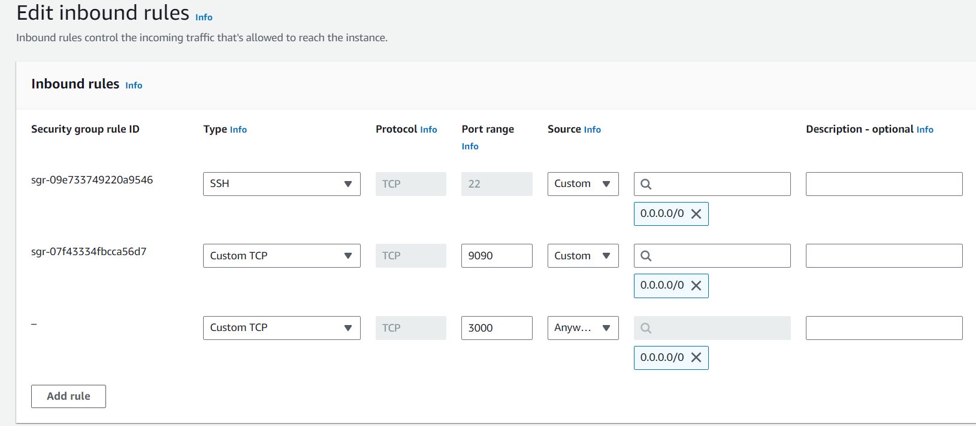

**As we can see grafana login page**

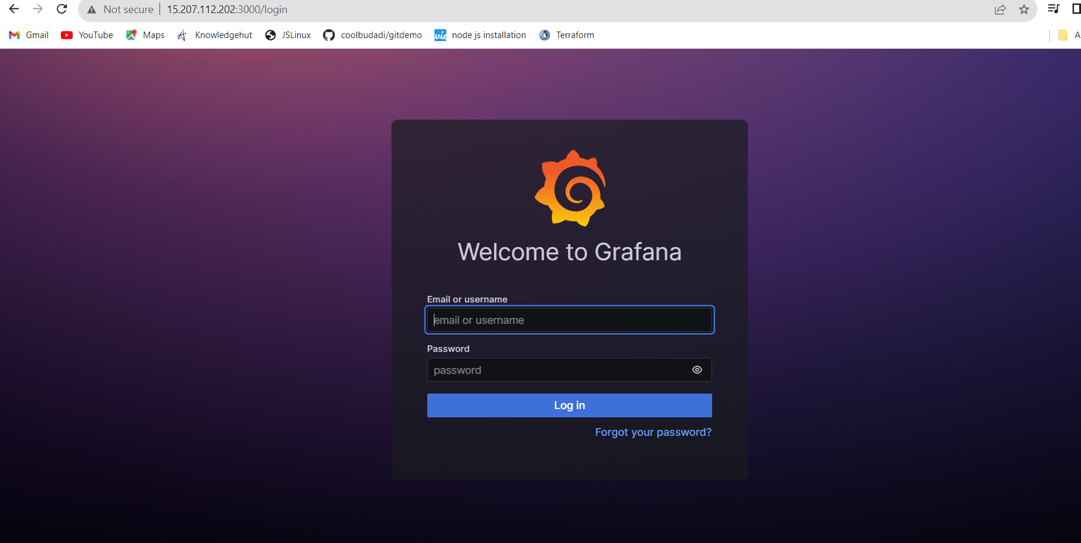

**Installed Nodejs on to the machine as application is based on nodejs**

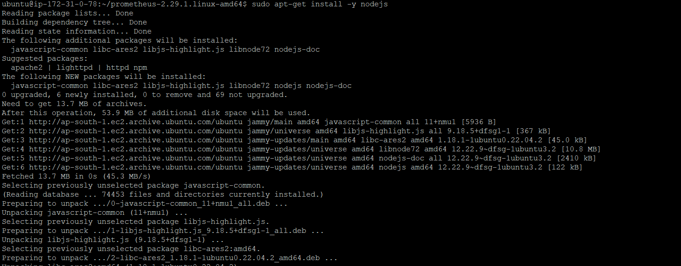

**Installed npm for building the nodejs code**

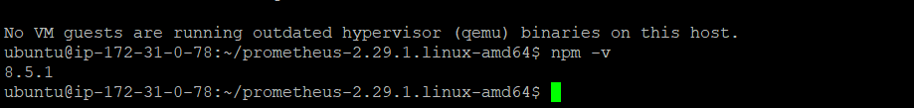

**Created a nodejs-Prometheus-app directory and navigate to it and initiate it using**

* **npm init -y**

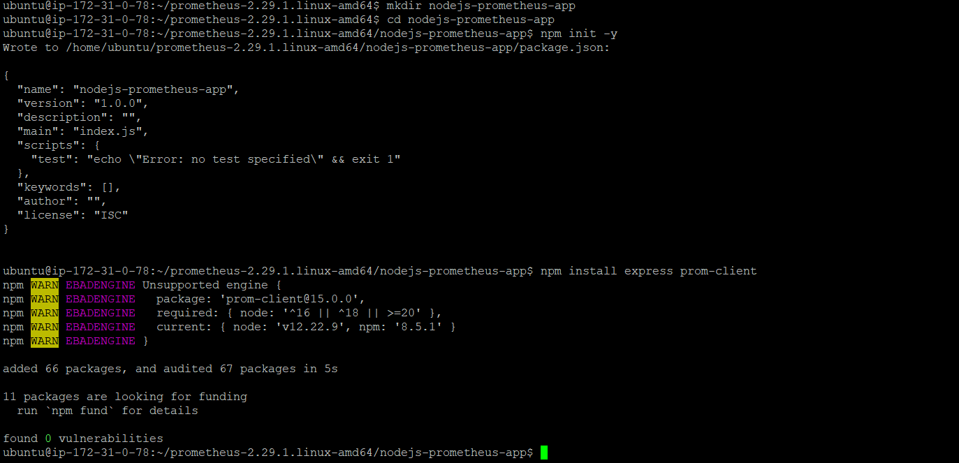

**Created a app.js file as below.**

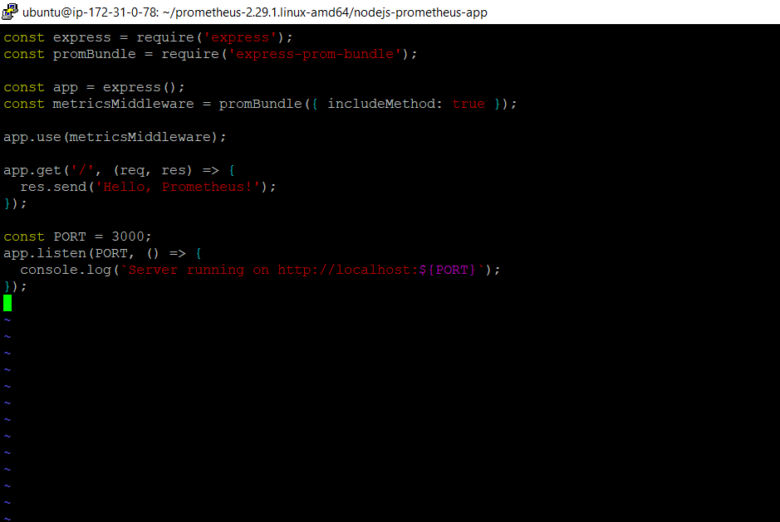

**Added entry of nodejsapp to Prometheus yaml file and started Prometheus using yaml file.**

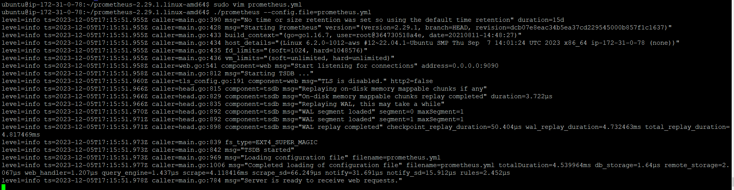

**After starting the Prometheus we could see nodejs-app added to the targets and showing status as up.**

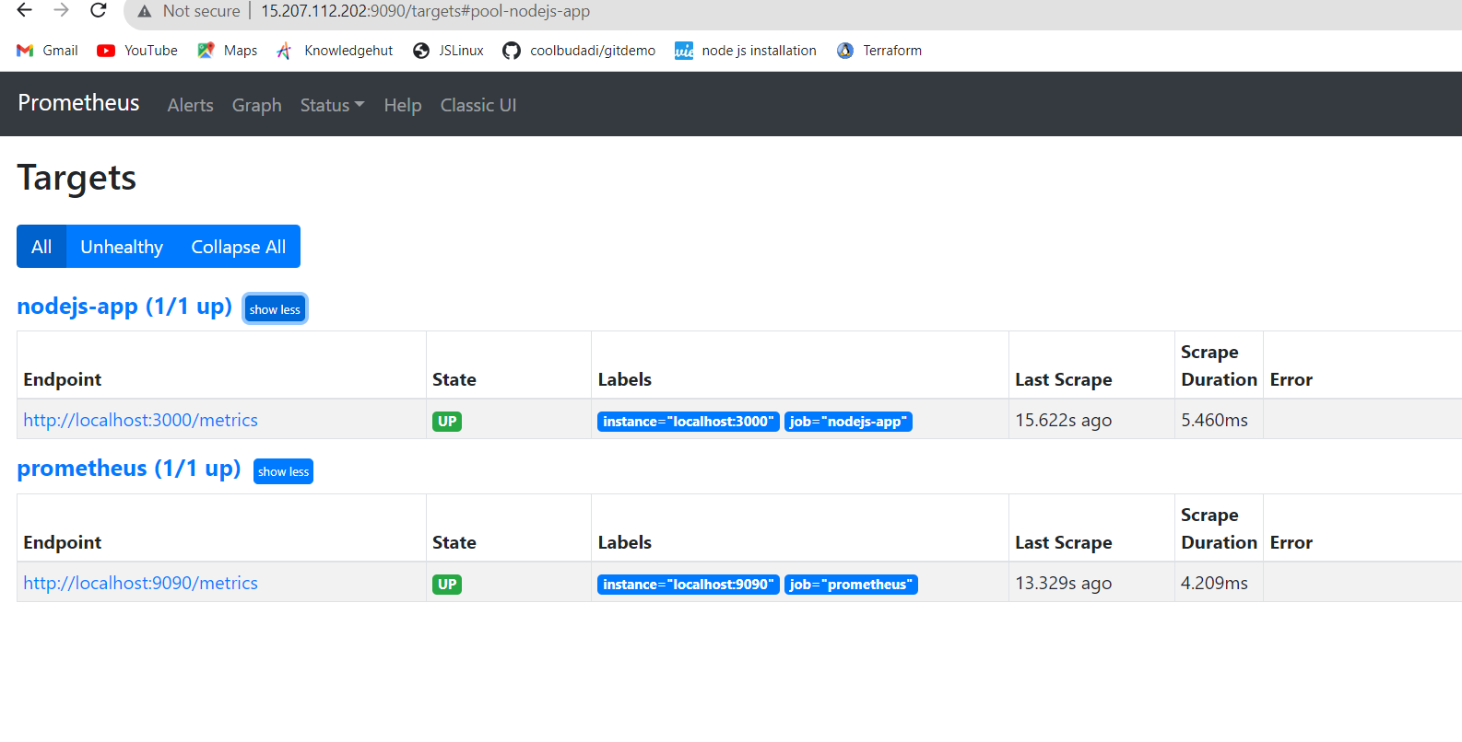

**Logged on to the Grafana dashboard .**

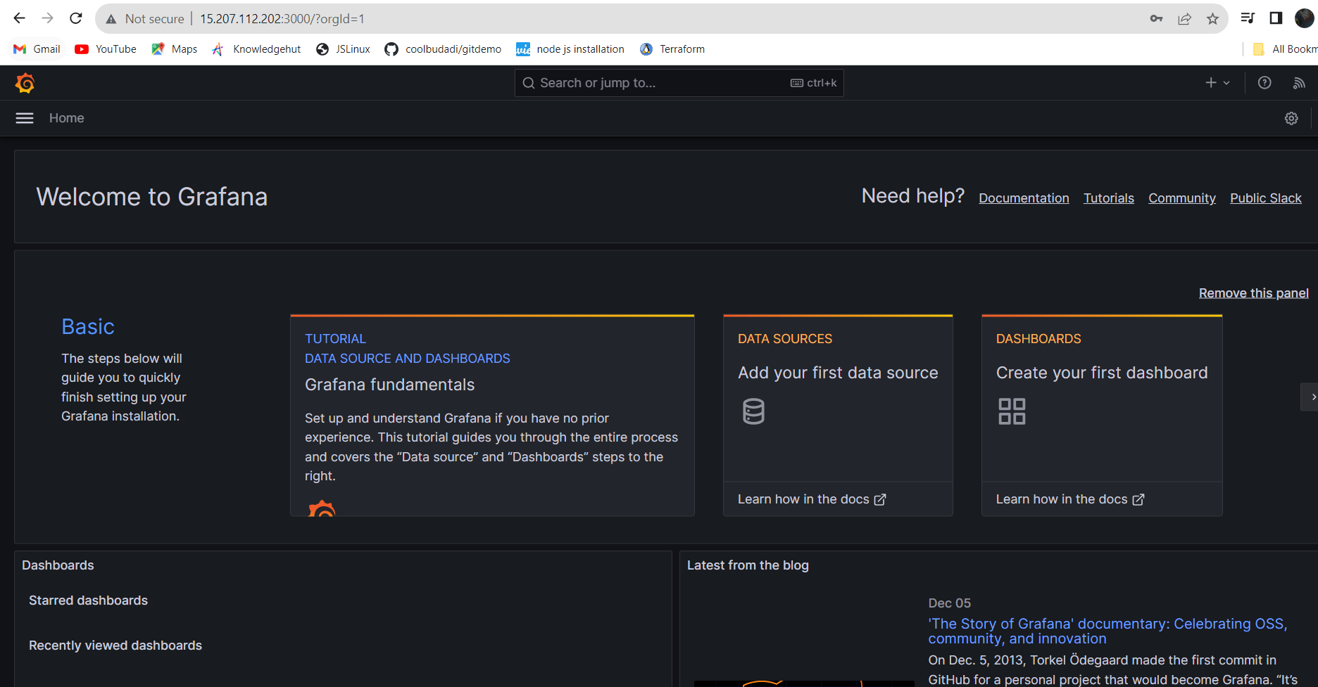

For creating a data source:

Connections > datasource > add datasource

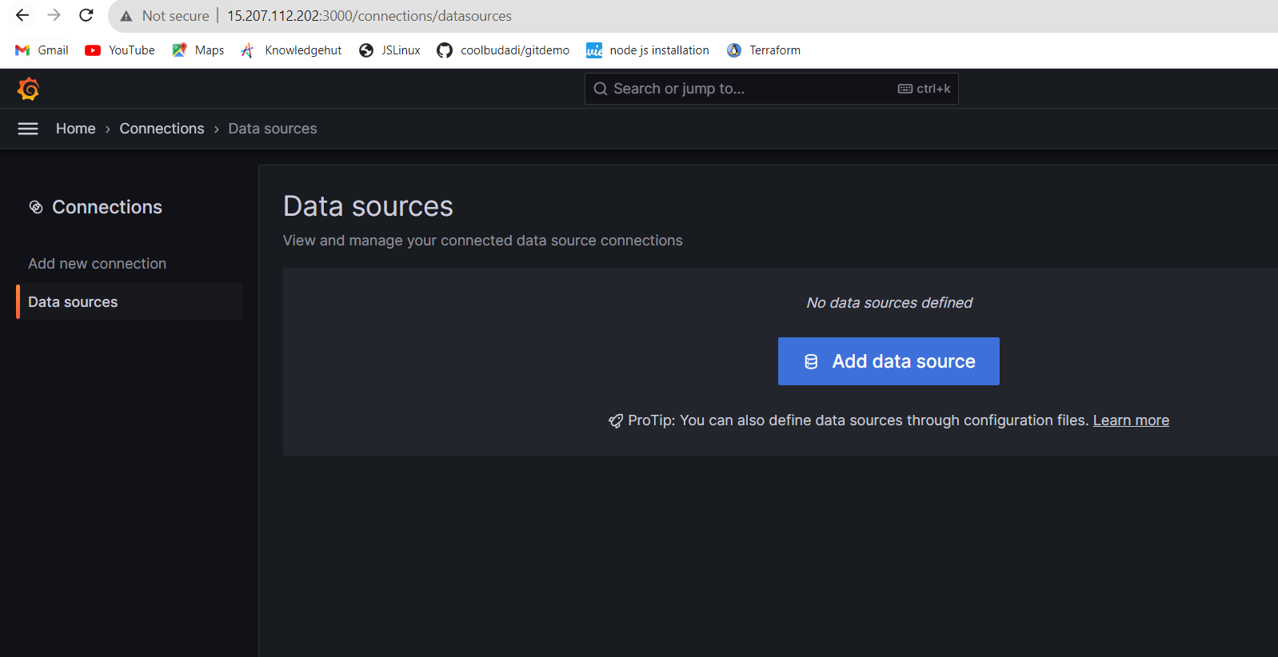

**And added Prometheus data source as below**

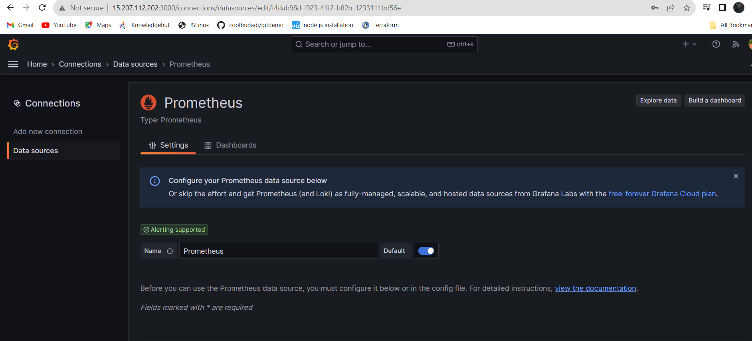

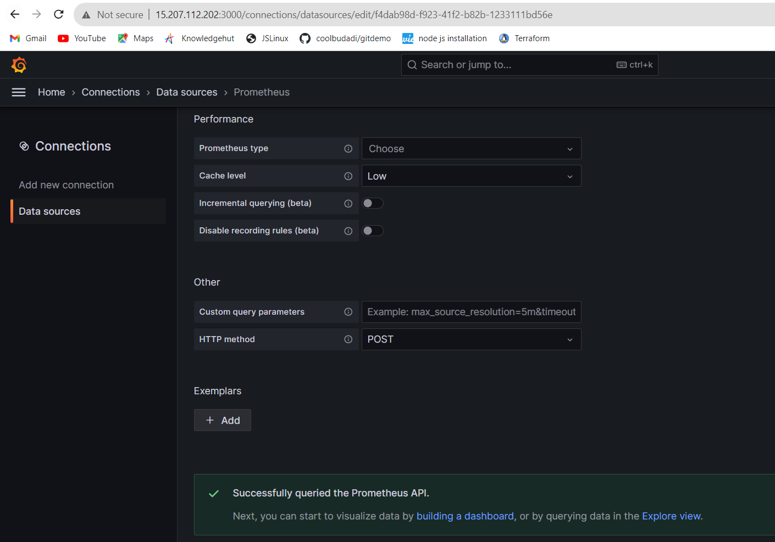

**Now for creating a Grafana dashboards visited Grafana dashboard and search for nodesjs metrics.**

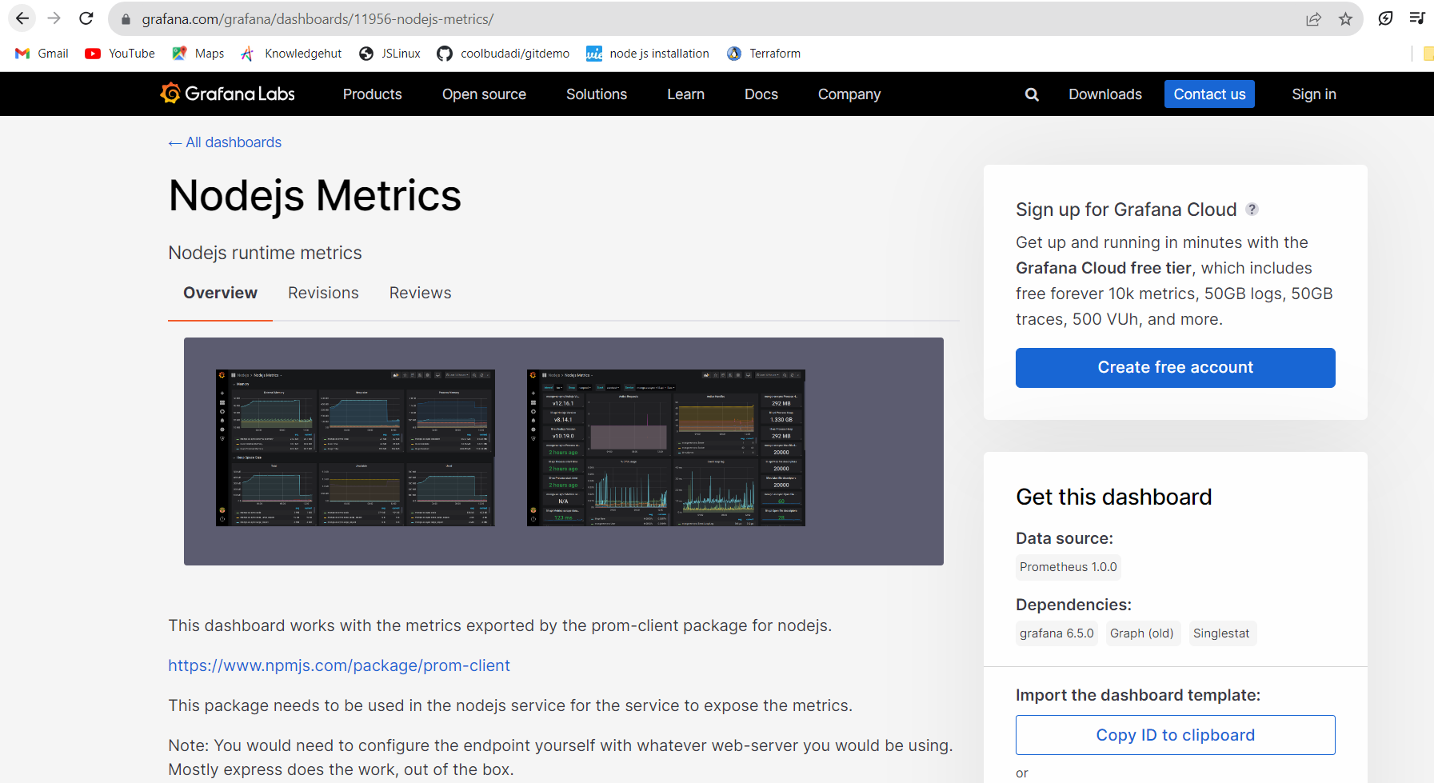

**Copied dashboard Id.**

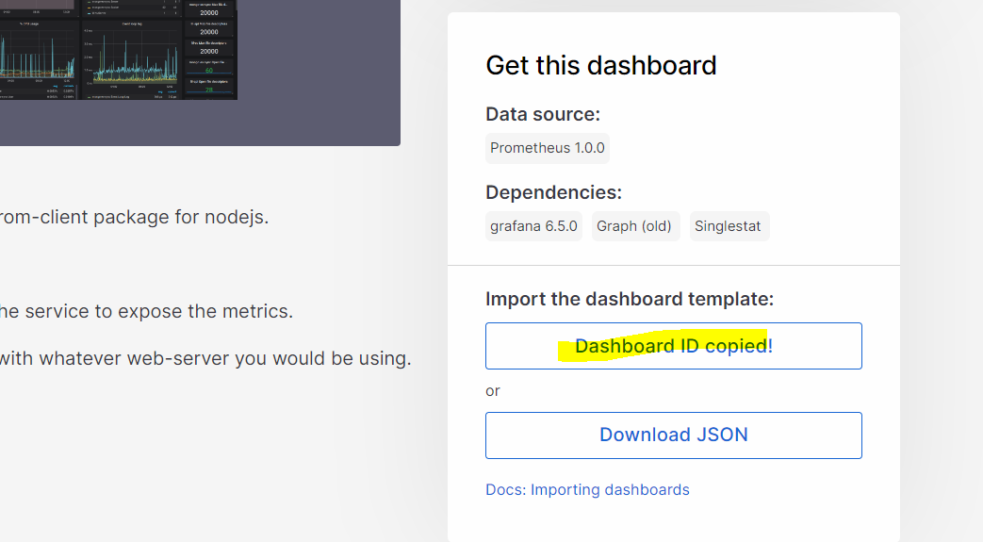

**Dashboards > New > import**

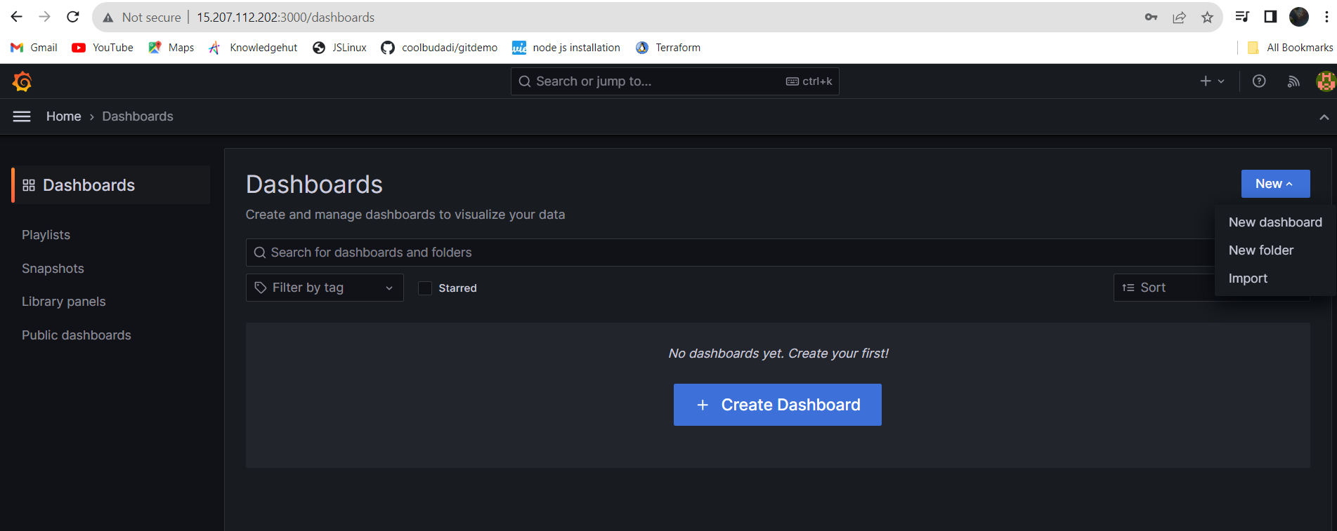

**Copy the dashboard id, select data source and import it.**

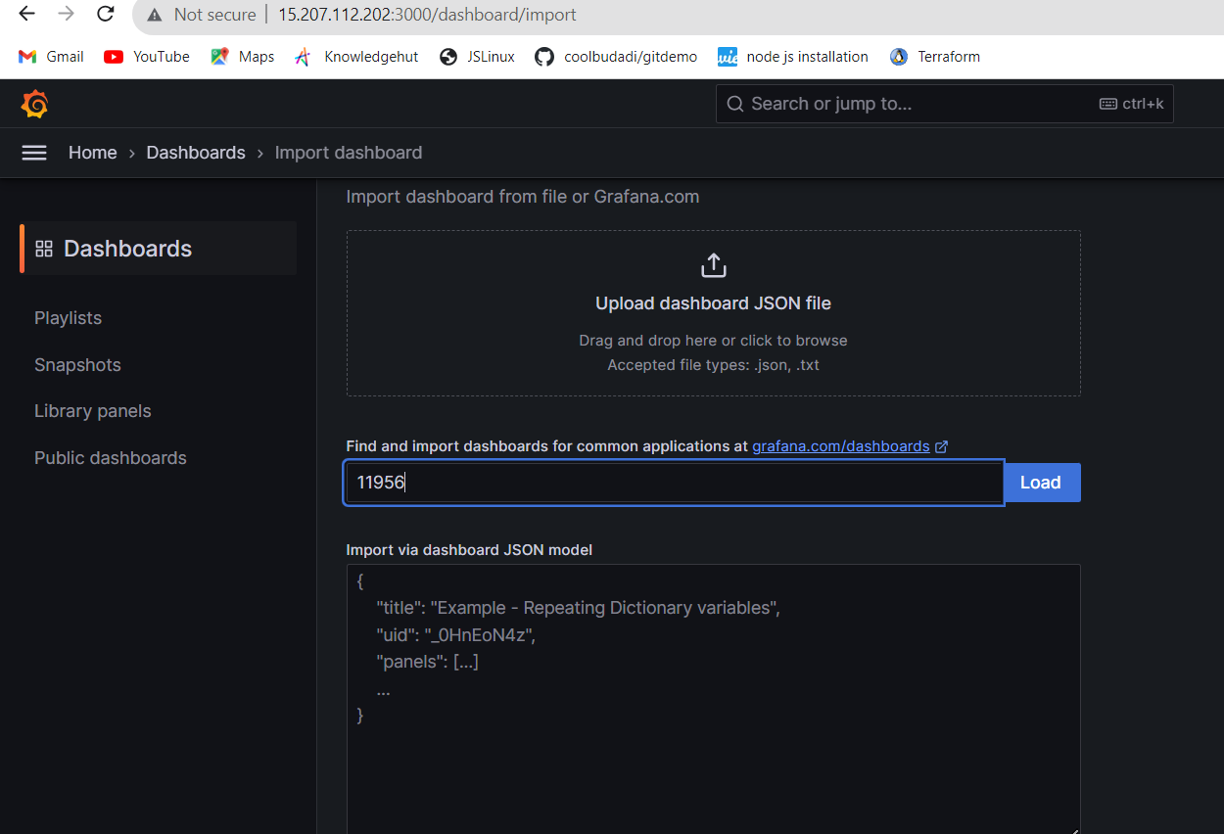

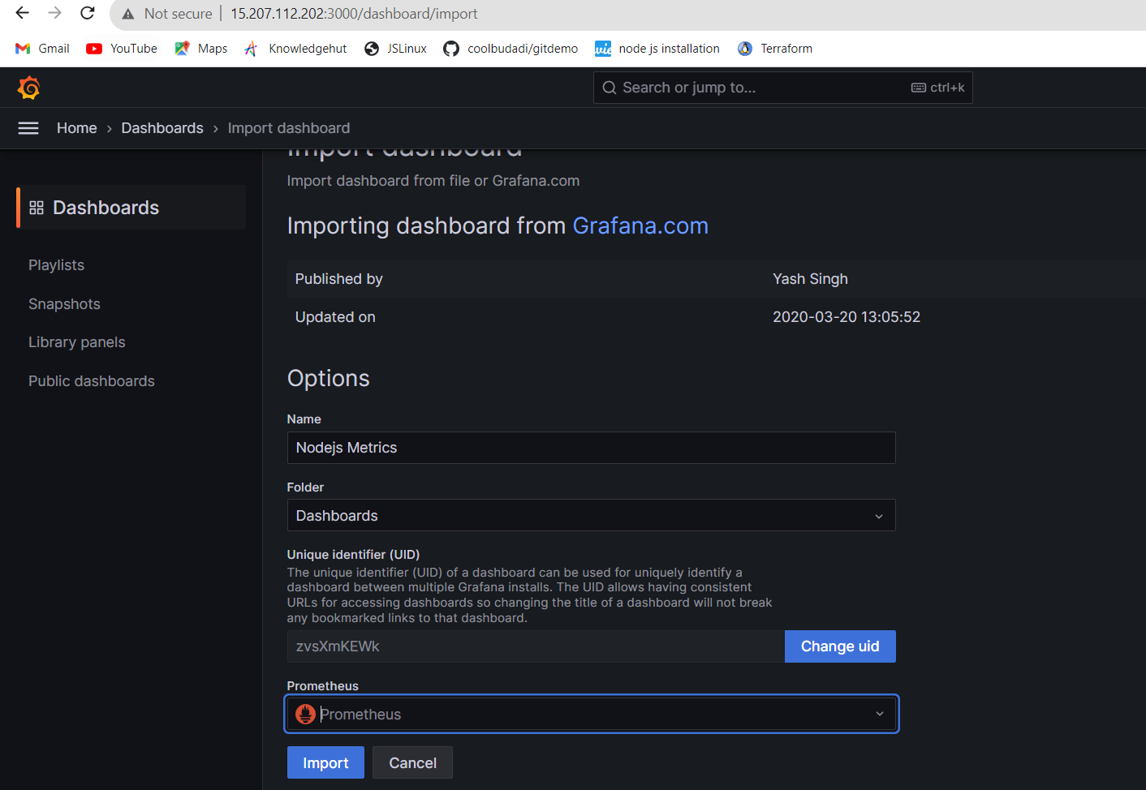

**Created a monitoring dashboard as below**

**Created for monitor process memory.**

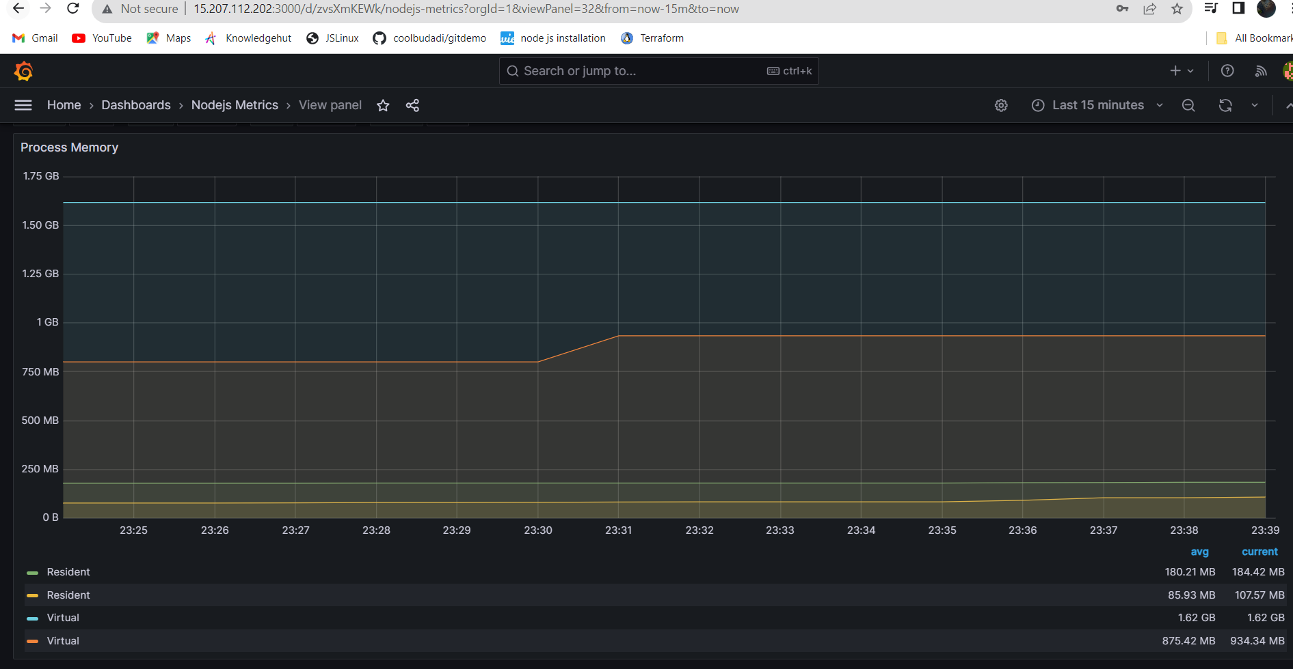

**Metric :scrape_duration_seconds**

**Label : instance**

**Host : 9090 and 3030**

